**Predicting Walmart Sales,**

**Exploratory Data Analysis, and**

**Walmart Revenue, Profit, and Customer Dashboard**

A Project Report Submitted

by

**Chandralega Shanmugam**

1. I have Predicted the Profit of Walmart using the power analysis and also represent the data in hierarchical as well as the area in a series of data points.

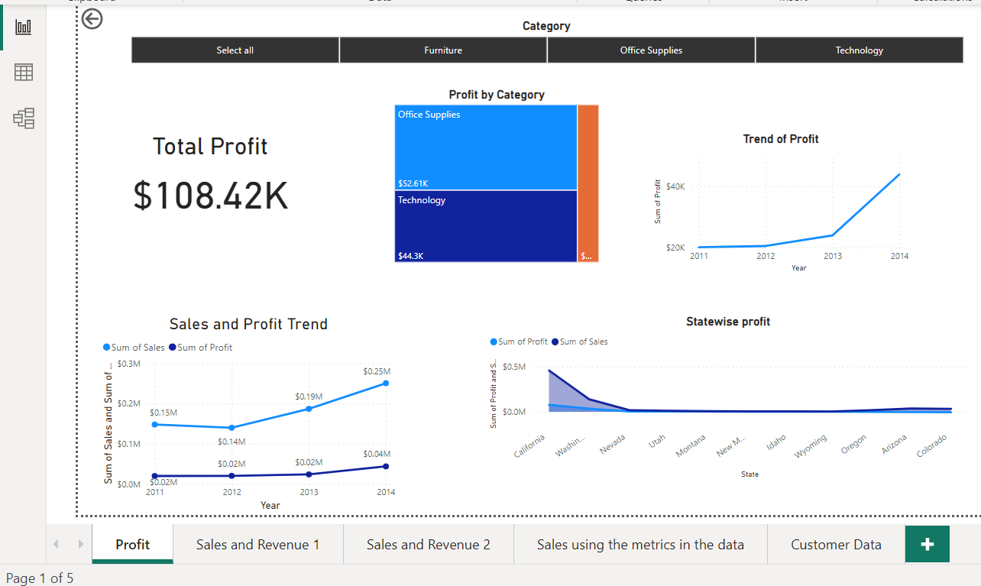

1. In this picture, the total profit of Walmart is 108.42K dollars.
2. I have created a slicer according to the category of products in order to select the particular category and get to know more insights about it.
3. I have created Treemap also using the category of products in order to select a particular category and get to know more insights about it.



* The Sum of Profit trended up, resulting in a 118.78% increase between 2011 and 2014.﻿﻿ ﻿﻿
* ﻿﻿The sum of Profit started trending up in 2011, rising by 118.78% ($23,834.9344) in 3 years.﻿﻿

﻿﻿ ﻿﻿

* The sum of Profit jumped from $20,065.6912 to $43,900.6256 during its steepest incline between 2011 and 2014.﻿﻿ ﻿﻿ ﻿



* The sum of Sales (69.48% increase) and Sum of Profit (118.78% increase) both trended up between 2011 and 2014.﻿﻿ ﻿﻿
* ﻿﻿Across all metrics, the Sum of Sales had the most interesting recent trend and started trending up in 2011, rising by 69.48% (102,749.49) in 3 years.﻿﻿ ﻿﻿ ﻿﻿
* ﻿﻿ ﻿﻿ ﻿﻿The sum of Sales jumped from 147,883.03 to 250,632.53 during its steepest incline between 2011 and 2014.﻿﻿ ﻿﻿ ﻿



* At $76,381.3871, California had the highest Sum of Profit and was 1,270.08% higher than Colorado, which had the lowest Sum of Profit at ($6,527.8579).﻿﻿ ﻿﻿
* ﻿﻿The sum of Profit and total Sum of Sales are positively correlated with each other.﻿﻿ ﻿﻿

California accounted for 58.44% of the Sum of Profit.﻿﻿ ﻿﻿

* ﻿﻿The sum of Sales and Sum of Profit diverged the most when the State was California when the Sum of Sales was $381,306.2444 higher than the Sum of Profit.﻿﻿ ﻿﻿ ﻿

**I have created a visual that would break down measures into underlying factors and analyze the sales using the metrics in the data.**

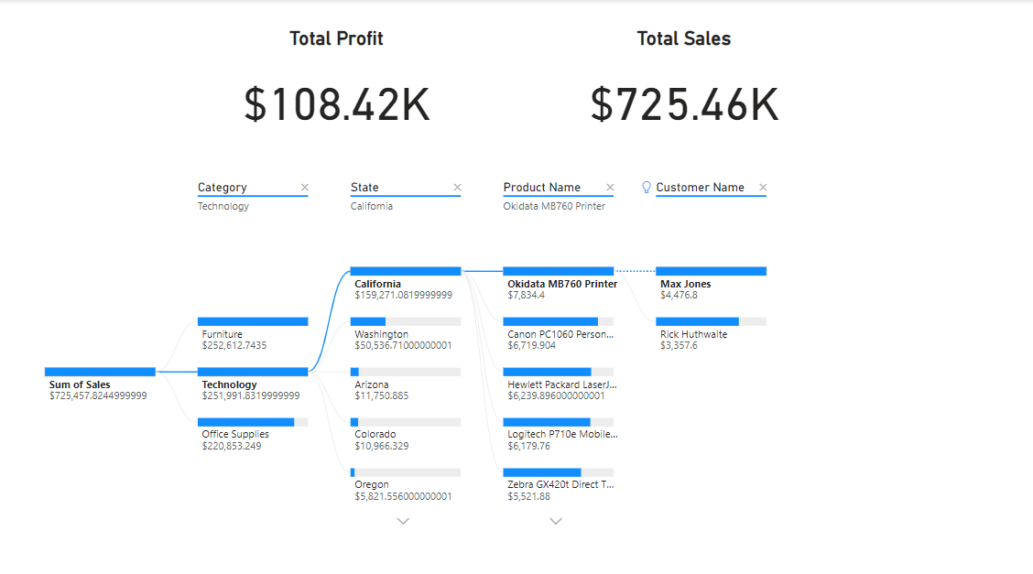

* In this Dashboard, the total profit of Walmart is 108.42K dollars, and the total sales of Walmart are 725.46K dollars.
* I have created a decomposition chart also using the sales category of products, state, product name, and customer name in order to get to know the highest and low values according to our Business requirements.

**Sales and Revenue: Tracked store's sales and revenue over time, by category, region, and product**

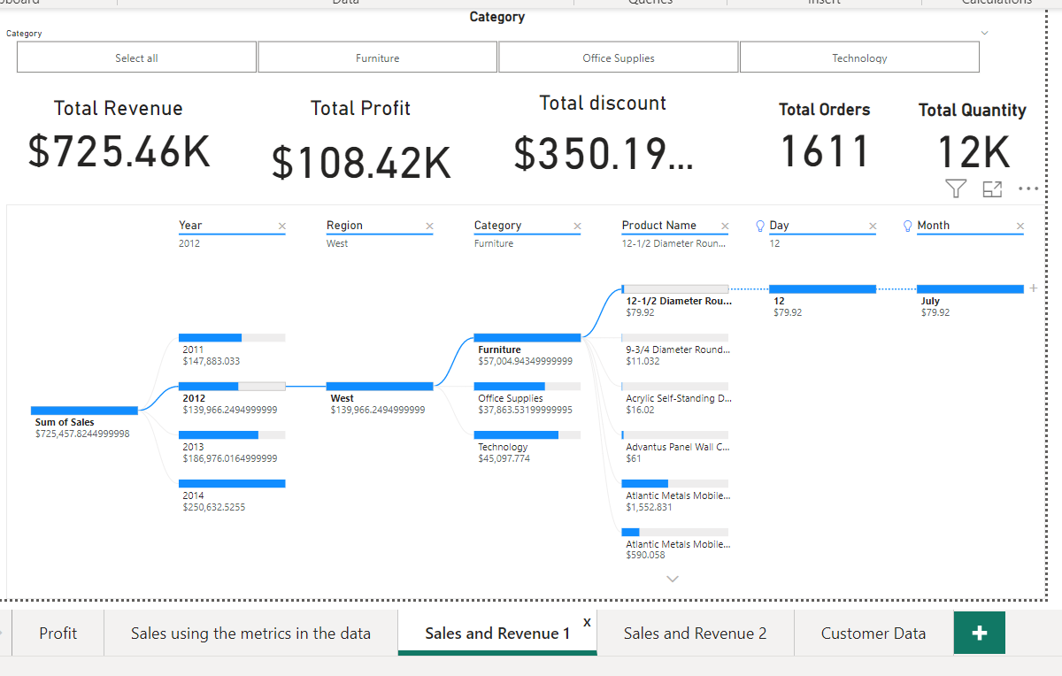

* In this Dashboard, the total profit of Walmart is 108.42K dollars, the total sales of Walmart are 725.46K dollars, the total discount is 350.19 dollars, the total order is 1611 and the total quantity of the order is 12k.

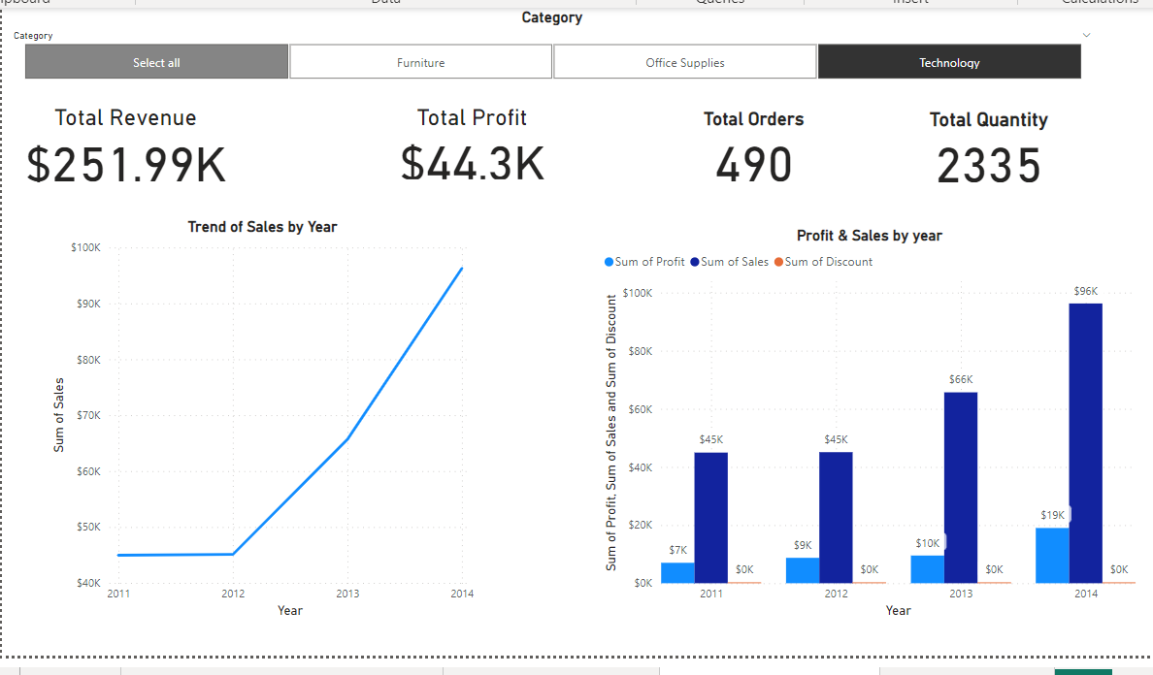

* In this Dashboard, the total profit of Walmart is 44.3K dollars, the total sales of Walmart are 251.99K dollars, the total order is 409 and the total quantity of the order is 2235 as I have chosen only Technology sales.



* The sum of Sales trended up, resulting in a 114.13% increase between 2011 and 2014.﻿﻿
* ﻿ The sum of Sales started trending up in 2011, rising by 114.13% ($51,307.79300000001) in 3 years.﻿﻿ ﻿﻿ ﻿﻿
* ﻿﻿The sum of Sales jumped from $44,953.731 to $96,261.524 during its steepest incline between 2011 and 2014.﻿﻿ ﻿﻿ ﻿



* Across all metrics, the Sum of Sales had the most interesting recent trend and started trending up in 2011, rising by 114.13% (51,307.79) in 3 years.﻿﻿ ﻿﻿ ﻿﻿
* ﻿﻿The sum of Sales jumped from 44,953.73 to 96,261.52 during its steepest incline between 2011 and 2014.﻿﻿ ﻿﻿ ﻿

**Customer Insights:**

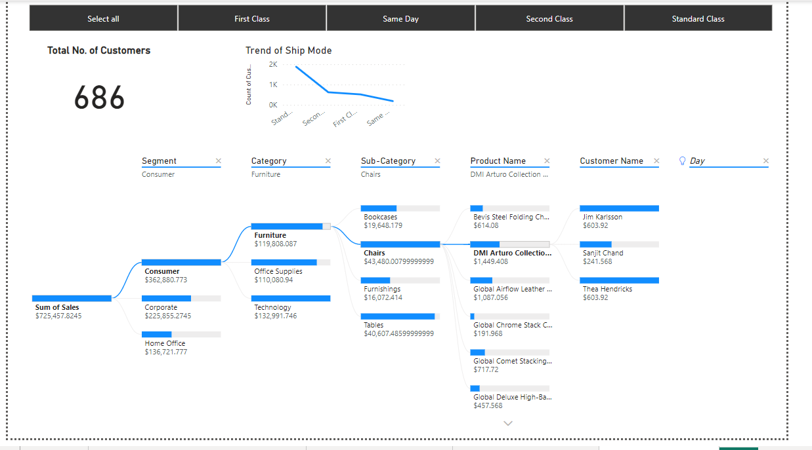

In total, there are 686 customers.



* At 1,882, Standard Class had the highest Count of Customers and was 917.30% higher than Same Day, which had the lowest Count of Customers at 185.﻿﻿ ﻿﻿ ﻿﻿
* Standard Class had the highest Count of Customers 1,882, followed by Second Class, First Class, and Same Day.﻿﻿ ﻿﻿ ﻿﻿
* Standard Class accounted for 58.76% of Customers.﻿﻿
* ﻿﻿﻿Across all 4 Ship Modes, the Count of Customers ranged from 185 to 1,882.﻿﻿ ﻿﻿ ﻿



* Apart from that, I have created a Decomposition tree to get to know more about customers using sales, segment, category, sub-category, product name, and the highest value and lowest value of customers for a particular product.